Joseph Silva Jr.

09/25/2021

SNHU

IDS 403 Milestone Two

**History Lens Analysis:**

The Oculus company was purchased by Facebook Technologies, LLC in 2014 for 2 billion dollars. The virtual reality device allowed Facebook to take it first steps in the pathway to enter the metaverse and many other big techs followed in order to have their part in creating the metaverse. These big techs state the metaverse is the future of the internet. The metaverse is a 3D universe which is created through the use of different realities such as virtual reality, augmented reality, extra reality, and mixed reality. These realities allow humanity and 3D internet designs to be combined to allow the user the ability to view and enter the metaverse.

In 2018, the general public got a glimpse of the metaverse through the sci-fi film “Ready Player One”. Ready Player One is about an “orphaned teenage hero flees his bleak real-world existence by immersing in a dazzling virtual reality fantasy. The boy straps on his headset, reminiscent of a pair of VR goggles, and escapes into a trippy virtual universe, dubbed OASIS. (4)” The equipment used by the main character in Ready Player One is a similar design to the Oculus Quest VR device, which was released in 2019 to the general public. The Oculus Quest 2 device was released by Facebook and the device allows virtual reality to be visualized and interacted with by users. Facebook went from a major social media platform to one of the first companies to enter the metaverse by using the Quest 2 and a Facebook social media account.

At first, the Quest 2’s user did not have to worry about having a Facebook account to access virtual reality, but the company has changed its mind by requesting each user to have an account by the year 2023. Facebook is going to be going all in to gain access to the metaverse with the use of Quest and it will register the users through their social media accounts. These open new possibilities by allowing a creation of a metaverse 3D market which can allow users to purchase items for the real world through cryptocurrency. Facebook is ready to lead society and other big techs into the metaverse with the help of their new CTO Andrew Bosworth, who is head of the AR/VR division of Facebook.

The creation of devices allows us to see an issue in society and it has been an issue for a long time. An individual desire to escape our own personal reality and leave behind the daily stress. The Quest 2 allows general users to leave a world filled with limitations and enter the digital frontier.

**Humanity Lens Analysis:**

The Oculus Quest 2 is one of the few gateways that allow individuals to enter a reality where the development of worlds and characters are only limited by one’s imagination. The development of devices like quest 2 has affected my personal life, but not my professional life. I can see my younger siblings avoid in-person society and they prefer contacting other individuals within the different realities accessibly by The Quest 2. The Quest 2 allows people to connect with each other, no matter the distance, through applications used by these devices. These applications give users the ability to see the beauty of other users’ culture by apps such as “The American Experience by Boulevard” (2) or to see the imagination of other users by the app “VRchat”. With VRchat, users can see virtual reality worlds created by programmers and they can see avatars created by other users. During my research, I found a YouTube video showing the top 10 VRchat avatar worlds (1) and these worlds are compatible with the Quest 2 device. The VRchat avatar worlds can be accessed by Quest 2 to allow users to meet up with other users by using created and modified avatars. These worlds allow the programmer to create new realities through visual arts and the Quest 2 allows the users to become a part of these visual art worlds. While watching the video, the two worlds I saw with the best artwork out of the 10 worlds were Jelly’s Random Avatar World and City 17. Please see the example below to see a distilled image of the Jelly’s Random Avatar World of a customized avatar.

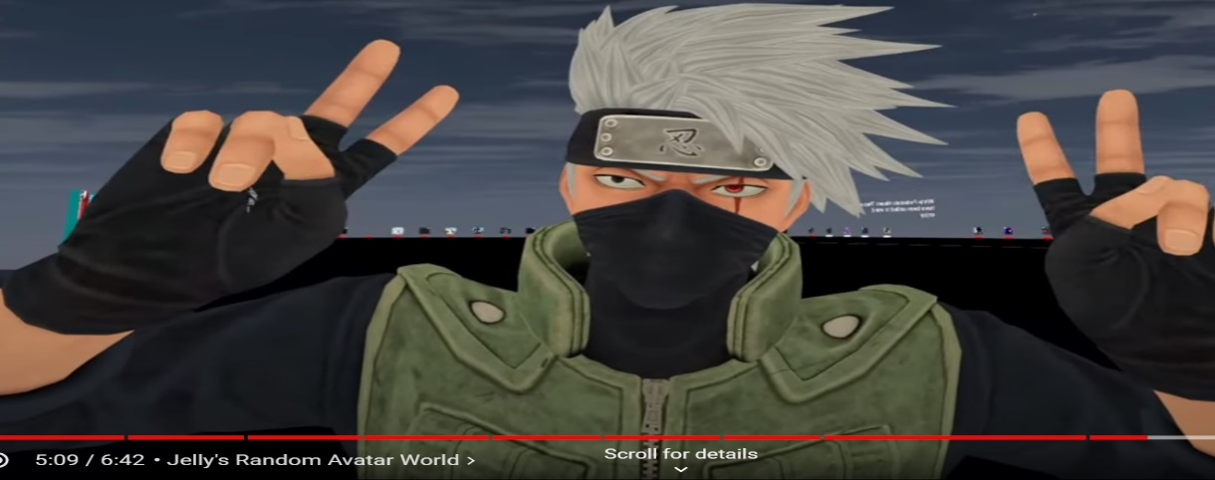 (1)

The ability to customize the avatars in these worlds allows any person, regardless of their programming or artist ability, to become a user and to create a character from the user’s imagination. I believe devices like Quest 2 give a message to society and the message is humanity will no longer be limited to only God’s imagination.

**CITATION:**

1. YouTube. (2021). *YouTube*. Retrieved September 26, 2021, from <https://www.youtube.com/watch?v=e_Y5y2X3YYc>.
2. *American experience by Boulevard on oculus go*. Oculus. (n.d.). Retrieved September 26, 2021, from https://www.oculus.com/experiences/go/1545812398780175/.
3. Newton, C. (2021, July 22). *Mark in the Metaverse*. Retrieved September 27, 2021, from <https://www.theverge.com/22588022/mark-zuckerberg-facebook-ceo-metaverse-interview>
4. Brown, D. (2021, September 1). *Big Tech wants to build the 'metaverse.' what on Earth does that mean?* The Washington Post. Retrieved September 27, 2021, from https://www.washingtonpost.com/technology/2021/08/30/what-is-the-metaverse/.
5. Cao, S. (2021, September 23). *Facebook enters 'metaverse' in full force as AR/VR chief takes over as CTO*. Observer. Retrieved September 27, 2021, from https://observer.com/2021/09/facebook-replaces-cto-andrew-bosworth-ar-vr-metaverse/.